**Transient Stability**



**Javier Jesús Macossay-Hernández**

**EE443 – Introduction to Power Systems**

**University of Southern California**

**Professor Robert Castro**

**Objective**

In power engineering, transient is a momentary variation in current, voltage, or frequency. In this problem, the transient stability analysis will be demonstrated and explored.

**Introduction**

The transient stability analysis will be applied in Design Case 2, which is a balanced three-phase power system in PowerWorld.

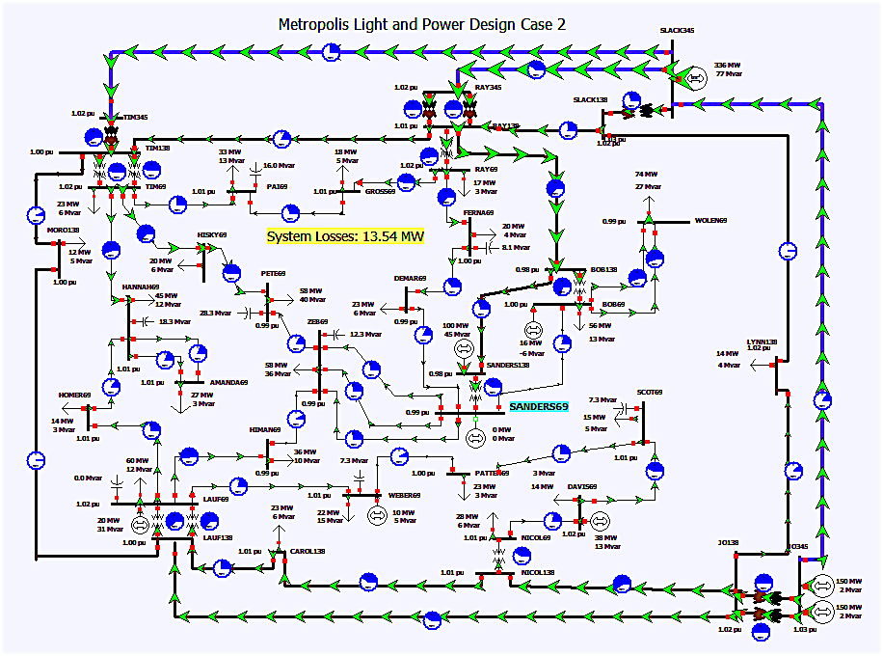

Fig. 1: The overall schematic of the circuit is shown.

**Methods**

A generator model in the system must have a machine stability model associated with it in order to do a stability analysis. The generator selected to be analyzed is “WEBER 69”

We will specify a machine model by right clicking it and selecting “Generator Information Dialog” and the “Generator Options Box” will be presented as shown in Figure 2.

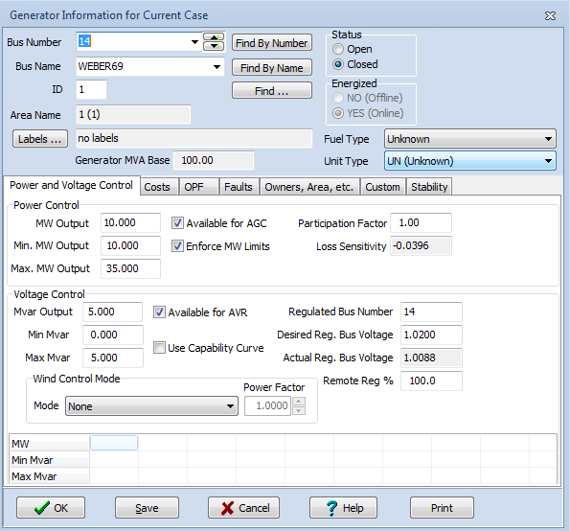

Fig. 2: Generator Options Box.

On the right side on the tab level, we can find the “Stability” tab. After selecting this tab, the options for the generator machine model will be shown to the user.

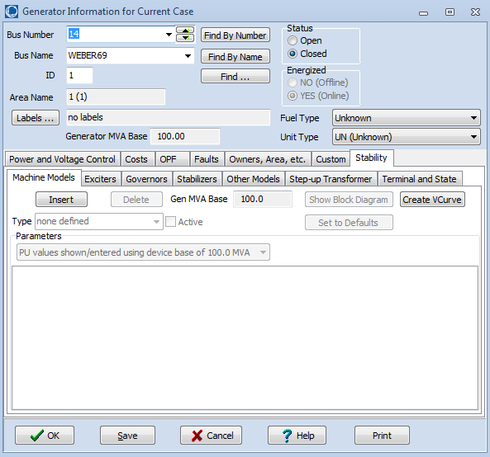

Fig. 3: Generator Information for Current Case

We will specify the machine model for this generator by clicking the “Insert” button. Next, the user is presented with the Model Type selection box. With PowerWorld help, we will be able to locate the GENCLS Machine Model Blog Diagram. This diagram represents a classical synchronous machine model, which will be used for the analysis of this problem.

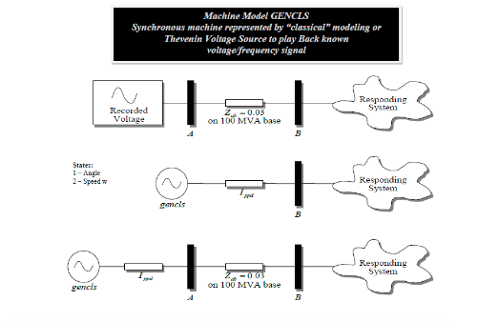

We select the model from the Model Type as shown and, then, click “OK.” Then, the default machine model parameter for GENCLS is presented to the user as shown in Figure 4. Next, click “OK.”

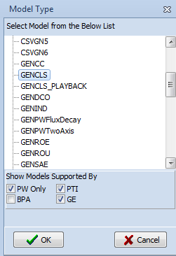

Fig. 4: Default machine model parameters for GENCLS.

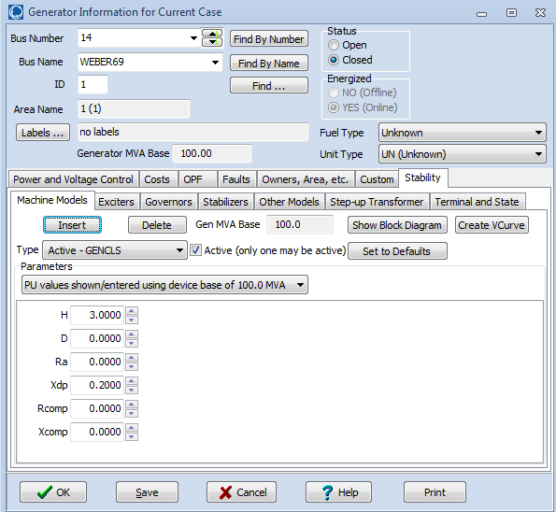

After putting the simulation on Run Mode, we select “Transient Stability” option, Figure 5, from the “Add Ons” tab of PowerWorld’s ribbon interface.

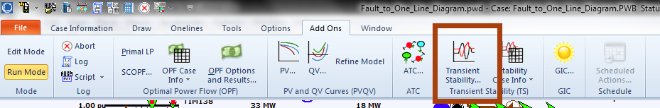

Fig. 5: “Transient Stability” Option

We will modify the Simulation Time Value to the ones shown in Figure 6.

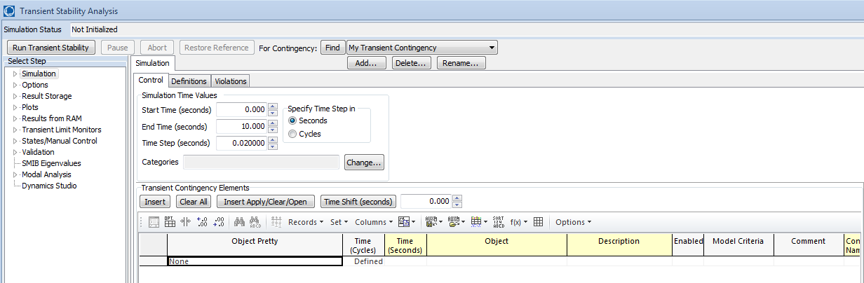

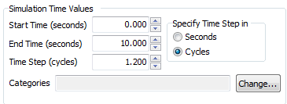

Fig. 6: Simulation Time Values

We will modify the Power System Model Options, selecting “Options” and, then, “General” to implement modeling of the slack busses as infinite busses. By doing this, the model can be assumed that the busses have fixed parameters such as voltage, magnitude, angle, and frequency.

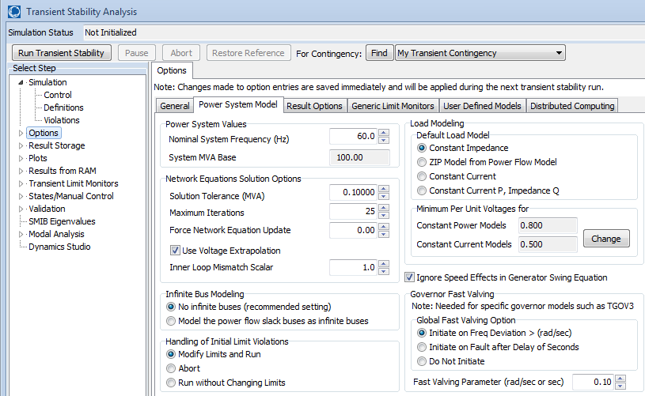

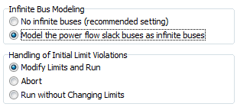

Fig. 7: “Infinite Bus Modeling” Option

In the “Simulation” section, a fault to be analyzed must be defined. We select the “Insert Elements” button from “Transient Contingency Elements,” and we are presented with the “Transient Stability Contingency Element Dialog,” shown below.

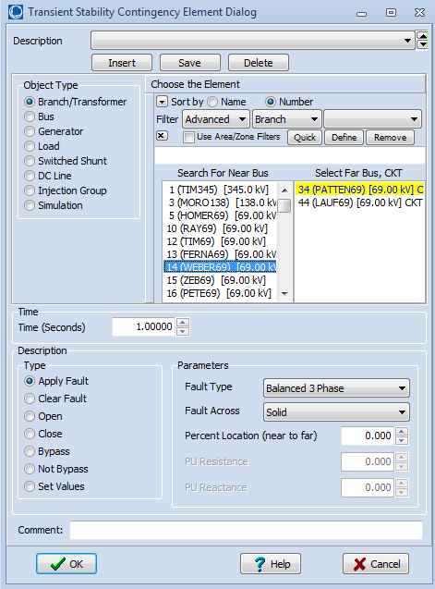

Fig. 8: “Transient Stability Contingency Element Dialog” Box.

**Calculations**

We will use a 3-phase bolted fault at WEBER69. We clear the fault by selecting the “Clear Fault” radio button and choosing Insert. Because we want this fault to clear in 5 cycles, we specify the clearing event time at 1.08333 seconds.

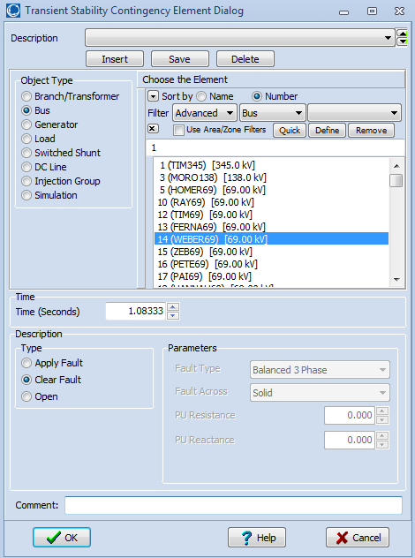

Fig. 9: Type Option and Time Value

The “Transient Stability Analysis” window confirms the additions.

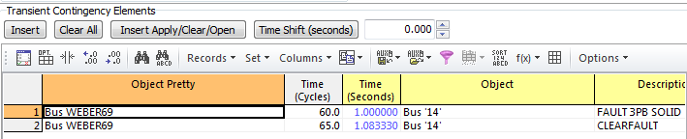

Fig. 10: “Transient Stability Analysis” Box

**Results**

In the Plot Designer Tab, we can produce the output plots of the WEBER69 generator angle, real power, and reactive power by choosing “Run Transient Stability” and, after that, “Generate Selected Plots.”

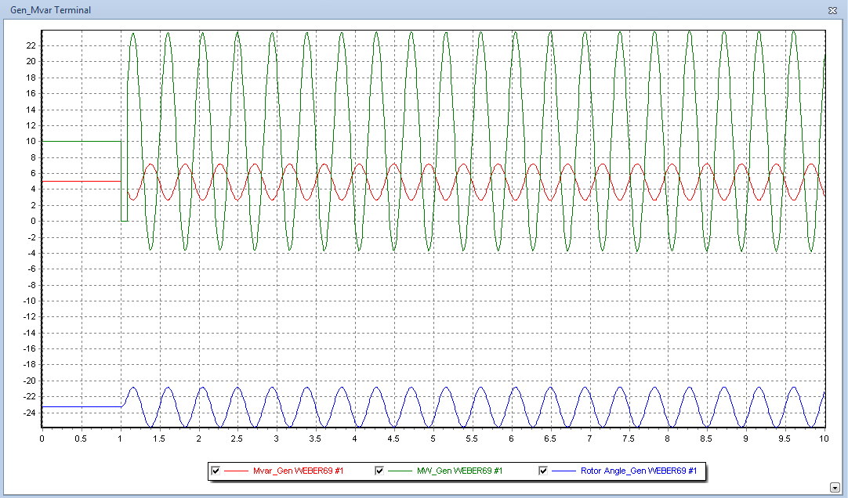

Fig. 11: Output Plots of the WEBER69 Generator Angle

To produce a subtler ringing, we modify the parameters as shown in the figure below. Additionally, the machine model of the WEBER69 generator will be changed to the GENROU model as shown in the figure below.

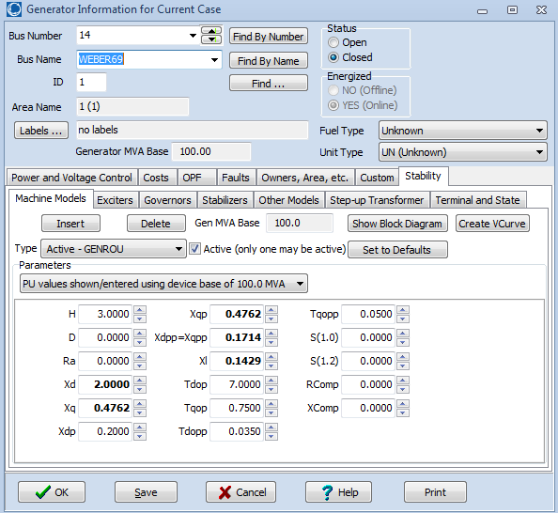

Fig. 12: Modifications to the Machine Model Parameters

Going back to the “Transient Stability Analysis” function and performing the same analysis creates the following plots. With the modifications, the system regains stability at 4 seconds.

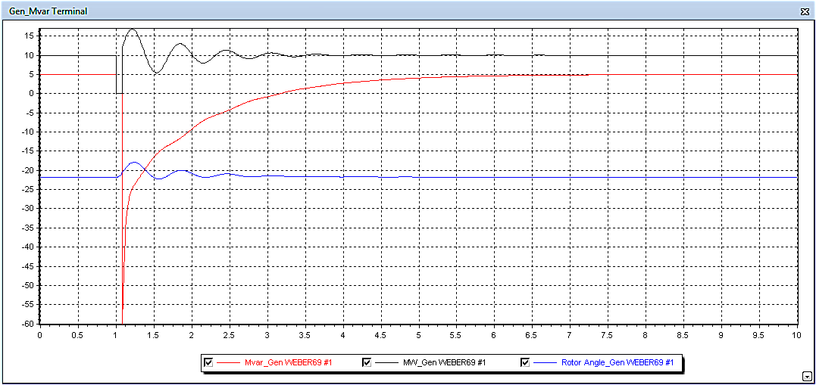

Fig 13: Output Plots with Modifications

**Discussion**

This problem enlightens the usefulness of the PowerWorld suite by exploring its applicability in an advanced concept of transient stability. To operate a power system effectively and efficiently, we, as engineers, must ensure the system’s stability. This concept is, in short, the power system’s capability of returning to a normal operating condition after an electrical disturbance. A system unable to cope with the latter will result in significant economic losses.